Diversification
You should diversify your investments because investing in one investment product is risky; this investment product might lose and accordingly you lose all your invested money. Don’t put all your eggs in one basket.
But what is risk? risk is the volatility of the investment you are in; how it fluctuates around its average. We express this by the standard deviation; standard deviation is how volatile something is. For example, assume there are two companies that made the following profits in 4 years:
Year | Company A | Company B
1 | 50% | 15%
2 | -40% | -5%
3 | 40% | 10%
4 | -30% | 0%

On average, both companies made a total profit of $20\%$and an average annual profit of $5\%$. However, the standard deviation of company A is $47\%$, while that of company B is $9\%$. So here, it is preferred to invest in company B as it is less risky; it is less volatile. Company A’s returns fluctuate much higher than that of company B. This is more intuitive when we draw both companies’ returns on the same plot as shown below. They both fluctuate around the same average, but company A is more aggressive than company B.
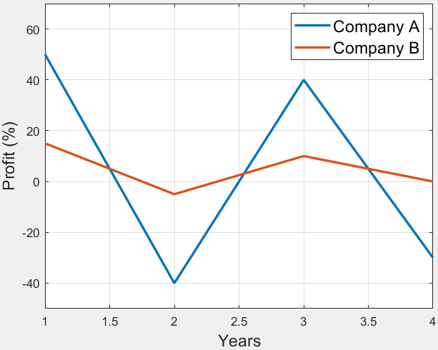
So, the less volatile the performance of a company is, the more safe it is. Now, consider this scenario: there are 2 companies that have exactly the same performance as shown below. In this case, would it be enough to invest in only one of them, or you still should diversify and divide your investments on both?
Year | Company A | Company B
1 | 50% | 50%
2 | -40% | -40%
3 | 40% | 40%
4 | -30% | -30%
Total | 20% | 20%
Average | 5% | 5%
Standard Deviation | 47% | 47%

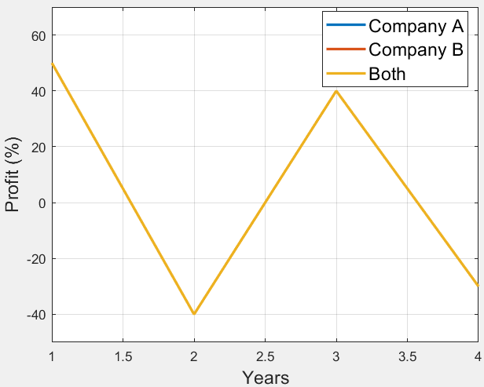
Since the two companies have exactly the same performance, it doesn’t matter whether you put all your money in one of them or divide it among both.
Now, assume we made a small change in company B’s returns as shown below. Notice that company B still has the same total, average, and standard deviation, we just swapped the profits of two years. In this case, is it still doesn’t matter whether you put all your money in one of them or divide it?
Year | Company A | Company B
1 | 50% | 50%
2 | -40% | -40%
3 | 40% | -30%
4 | -30% | 40%
Total | 20% | 20%
Average | 5% | 5%
Standard Deviation | 47% | 47%

It is less risky to divide your money among both companies. Why? Putting 50% of your money in company A and 50% in company B means:
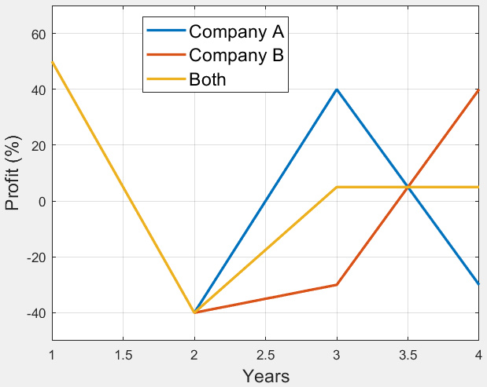
Year | 50% in Company A and 50% in Company B
1 | 50%
2 | -40%
3 | 5%
4 | 5%
Total | 20%
Average | 5%
Standard Deviation | 37%
See? The volatility of your investments decreased when dividing your money on both companies although both companies are as volatile.
Now, assume we made another change in company B’s returns as shown below. What happens in this case?
Year | Company A | Company B
1 | 50% | -40%
2 | -40% | 50%
3 | 40% | -30%
4 | -30% | 40%
Total | 20% | 20%
Average | 5% | 5%
Standard Deviation | 47% | 47%
Putting 50% of your money in company A and 50% in company B means:
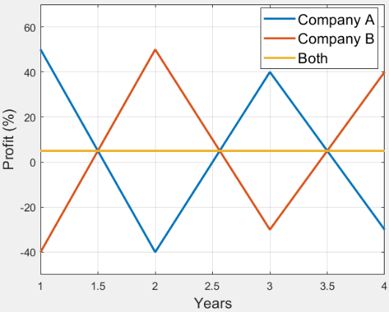
Year | 50% in Company A and 50% in Company B
1 | 5%
2 | 5%
3 | 5%
4 | 5%
Total | 20%
Average | 5%
Standard Deviation | 0%
See? The volatility of your investments decreased more and more!
But what is happening? Why does the volatility decrease although I am dividing my money among two companies that have the same volatility in all cases? It is because of the correlation between the two companies. As the correlation between the two companies decreases, the volatility of investing in both decreases. The correlation percentage between the two companies A & B in the 3 previous cases are:
Case | Correlation Percentage
1 | 100%
2 | 25%
3 | -97%

So, we basically reduce risk through diversifying our investments among many assets that are uncorrelated as much as possible. Ray Dalio, one of the best investors of all time, tells that the most valuable lesson he learned about investing is what he calls “The holy grail of investing”, which is basically the idea of diversifying your investments among uncorrelated investments. He explains his principle as follows: you are now building your investment portfolio. For sure, you want to get the maximum profit. So, assume you have many portfolios that guarantee you an average annual return of 2.5% (this is small, but this is what he assumes in his example). So, all these portfolios are equal in terms of the return. Then, which portfolio to choose? Since they have the same profit, we ought to risk. And how do we assess the risk of any portfolio? The risk of a portfolio is its annual standard deviation. So, we choose the portfolio with the least standard deviation. So, we are here given some portfolios that have the same profit but different standard deviations, so we chose based on the standard deviations. What if we are still building a portfolio, how can we build it such that we maintain the same average annual return of 2.5%, but try to minimize the risk (i.e. standard deviation) of the portfolio as much as possible? You have two degrees of freedom to play with when building a portfolio to reduce its risk assuming the average annual return will always be the same:
- Number of assets in the portfolio.
- Average correlation between the assets in the portfolio.
So, assume a single asset has an annual risk of 10% (i.e. 10% annual standard deviation). Now, what happens when you play with the number of assets and the average correlation between them? This is what Ray Dalio shows in his popular chart shown below. If you have only 1 asset of 10% risk in the portfolio, then your portfolio’s annual risk is 10%. If you start adding other assets while maintaining an average correlation of 100% between all these assets, you are doing nothing, your portfolio’s annual risk won’t change, it will remain 10% whatever the number of assets you add. However, what happens when you add more and more assets while maintaining an average correlation of 60%, 40%, 20%, 10%, and 0%? This is what is shown in the chart below. Assets within the same sector are usually 60% correlated, this is why Ray went up to 60% average correlation only.
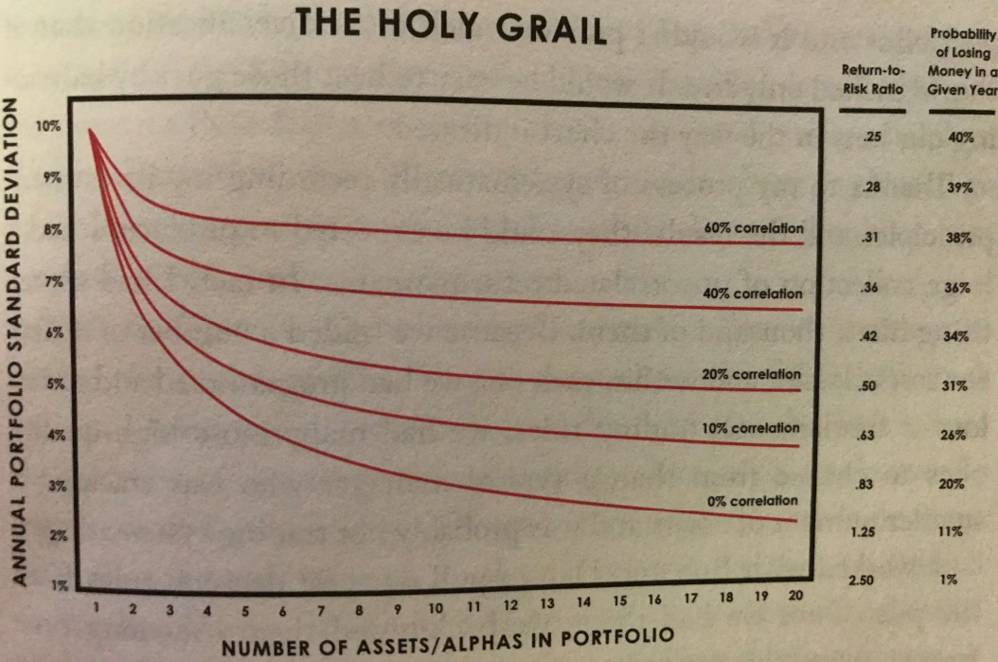
For any given average correlation, the more you add assets, the less the annual risk. That is, a portfolio with 15 assets having an average correlation of 60% has less risk than a portfolio with only 3 assets having an average correlation of 60%. So, for a constant average correlation, the more you add assets, the more you decrease your portfolio’s risk. However, as it is clear from the curves’ trend, for a given average correlation, the risk reduction percentage decreases as the number of assets increases. So, at an average correlation of 60%, going from 20 assets to 100 assets won’t reduce risk by much. Instead, try to target a lower average correlation. That is, instead of going from 20 assets to 100 assets at an average correlation of 60%, keep the number of assets 20 as it is, but try to achieve an average correlation of 20% instead. This is why Ray Dalio sees that putting 10-20 assets in the portfolio is enough, next try to achieve as small average correlation percentage as possible.
On the right, you can see the return-to-risk ratio and the probability of losing money in a given year for different annual risks. If your portfolio’s annual risk is 10% (in case of having 1 asset only), you have a return-to-risk ratio of 0.25 and a 40% probability that you might lose money in a given year (i.e. on average, you are not losing since we said that the average annual return is 2.5%, but there is a probability of 40% that you can lose in any given year). But if you managed to lower your portfolio’s risk to 2%, you now have a return-to-risk ratio of 2.5 and only 1% probability that you might lose money in a given year.
This shows how important diversification is. Putting all your money in one asset makes you at a 10% risk. Also, putting all your money in one sector even in many assets cause these assets to be 60% correlated, which reduces the risk but not by much (from 10% to 8%). But diversifying your investments across many sectors can let you achieve a 2% risk. So, compare being at a risk of 10% in case of 1 asset to a risk of 2% in case of 20 assets in different sectors; you reduced the risk by 80% while maintaining the same profit.

Sectors
The Global Industry Classification Standard (GICS) classifies sectors as:
- Energy.
- Materials.
- Industrials.
- Consumer Discretionary.
- Consumer Staples.
- Health Care.
- Financials.
- Information Technology.
- Communication Services.
- Utilities.
- Real Estate.
You can check the sectors map on Finviz as shown below. This is the sectors in the S&P500 index.
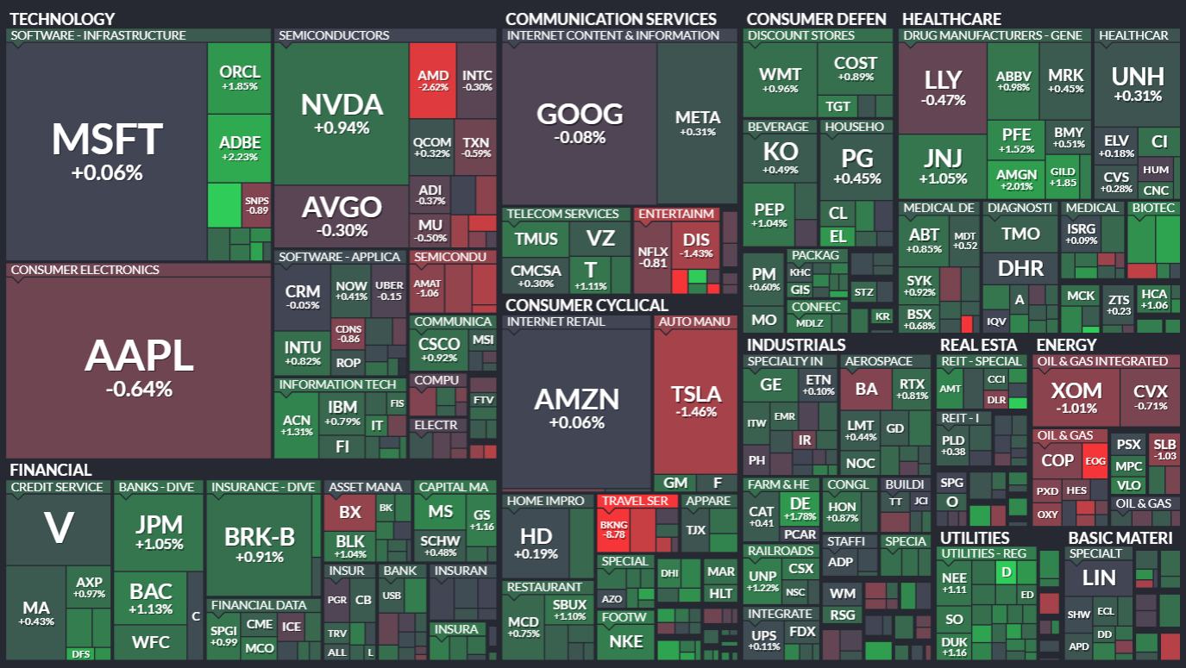
You can notice that the technology sector institutes the biggest portion of the S&P500 index. Of course, the portion of each sector changes from time to time, so you need to check periodically.

Business Cycle
The economy is like a roller coaster ride with its ups and downs. That is basically the business cycle. It is the natural pattern of expansion and contraction of the economy over time. There are 4 phases in a business cycle:
- Early phase: this is when the economy is growing, businesses are hiring more people, and people are spending money. It's like the upward climb of the roller coaster.
- Mid phase: at the peak of the cycle, the economy is at its highest point. It's like when the roller coaster reaches the very top before it starts to come down.
- Late phase: After reaching the peak, the economy starts to slow down. Businesses might cut back on hiring, and people might spend less. It's like the roller coaster starting to descend.
- Recession phase: This is the lowest point of the cycle. The economy is at its slowest, with high unemployment and less spending. It's like when the roller coaster hits the bottom before starting to climb again.
Then the cycle repeats itself. On Fidelity, you can check the business cycle in different countries. As shown below, the US business has been at the beginning of the recession phase for the last 4 quarters.
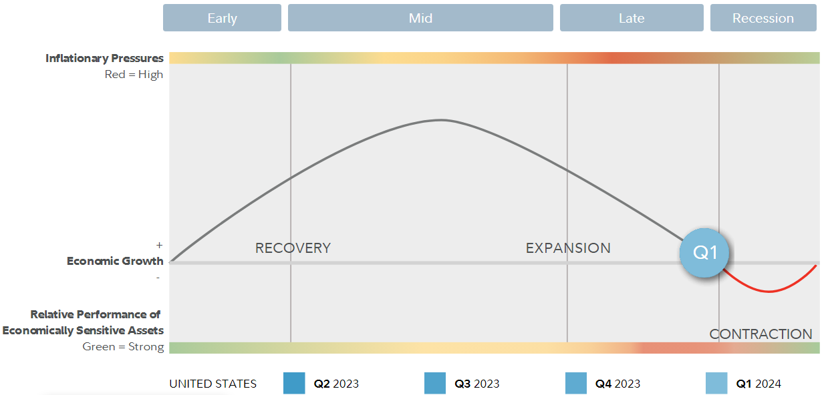
Sectors perform differently in each phase of the business cycle as shown below (signs and colors are relative to the market performance. So, a sector with 2 plus signs highly beat the market):
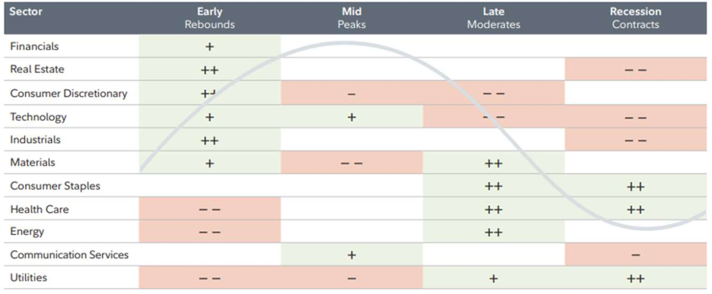
You can see that different sectors can beat the market in different phases. For example, in the recession phase where the market is not behaving well, you can see that consumer staples, health care, and utilities sectors are performing very well. You don’t really know which phase the market will be in the future. This is why it is very important to diversify your investments so that if one sector performs badly, others can outperform it.

The Top-Down Approach
In this approach, you start off at the complete top, basically looking at asset classes. So, you ask yourself “Do I want to invest in stocks? Is the market stable now and I can safely invest in stocks?”. Once you settled on investing in stocks, then you begin looking at different sectors. So, you ask yourself “Do I want to invest in the energy sector? Is there a potential that the energy sector will perform well in the future?”. Once you settled on the sectors you will invest in, then you begin looking at different industries under this sector. Deeper and deeper, you begin looking at securities under these industries.

The Economy, Fiscal, and Monetary Policy
We talked about the different phases of the business cycle and that it is so much related to how the economy of a country is performing. But how do we evaluate whether an economy is doing good or not? Through calculating the Gross Domestic Product (GDP). The GDP is simply the total value of all finished goods and services produced within a country in a year (finished goods means it will not be sold again as part of some other good). So, if a bakery bought eggs, flour, and sauces to make a cake, the ingredients are not counted in the GDP since they are unfinished goods, only the cake is calculated as a finished good. But if you bought eggs and ate it directly, then it is a finished good in this case and counts for the GDP. A healthy economy is the economy that has a growing Gross Domestic Product (GDP). So, there is a great correlation between a country’s GDP and its stock market because, if the GDP grows, this means more and more products are being sold in this country, and since these products are made by the companies in the stock market, so the stock market grows as well.
Now, assume a country’s economy is not doing well. That is, the people are not spending enough, so the GDP is decreasing, and the inflation rate is also decreasing. The government gets involved to help the economy through doing 2 things:
- Fiscal policy: the government tries to stimulate the economy through reducing tax rates so people have more money to spend to help the economy grow again.
- Monetary policy: each country/government has its own central bank. This central bank can be owned by the government or can be a private corporation. In Egypt, the central bank is owned by the government. In the US, the Federal Reserve System (simply “the Fed”) is the central bank, and it is a private corporation. A committee of the central bank of a country known as Monetary Policy Committee (MPC) meets many times during the year to make decisions about the monetary policy of a country. The MPC takes many decisions to help the economy. Two of the most well-known decisions are reducing the interest rates of the banks and printing new bank notes. Why does that help? Assume the interest rates are currently high in the banks. This encourages people not to spend money and put them in the banks so that they benefit from the high interest rate. So, less purchasing, lower GDP, hence the prices go down which results in lower inflation rate (lower than what the country targets). So, the central bank decides to decrease the interest rate and print new bank notes. Accordingly, people feel that it is no longer worth it to leave their money in the banks since they are making small interest. Instead, they take their money and spend it on goods, travelling, etc. Since people now buy more, so the GDP goes up. Since people are now buying more and the bank has printed more bank notes, the prices go up which results in higher inflation rate. When does the central bank decide to keep the interest rate as it is? When the government feels that the economy is currently stable and at a good inflation rate. Shown below is how the interest rate in the US changed over the last 25 years on this website. You can notice that the interest rate always decreases after economic problems. After the dot-com bubble in 2000, financial crisis in 2008, and the pandemic in 2020, the interest rate went down in a chance to help the economy grow again.
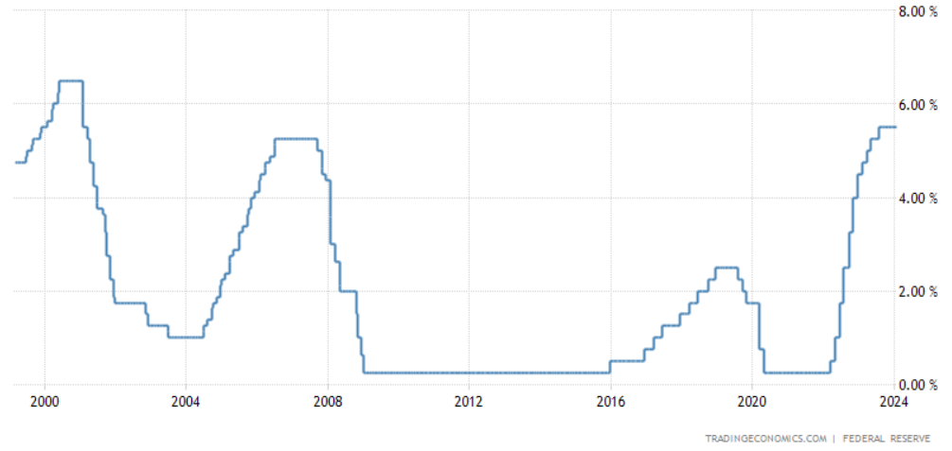
Now, we talk about each sector on its own. Each sector can have different industries under it.

Consumer Staples Sector
Consumer staples (السلع الاستهلاكية) are the everyday goods we buy like food, beverage, cleaning products, etc. We buy them whether the economy is doing good or not, and the amount we spend on them is relatively fixed.
Industry Group | Industries
Food & Staples Retailing | Food & Staples Retailing
Food, Beverage, and Tobacco | Beverages  Food Products  Tobacco
Household & Personal Products | Household Products  Personal Products
Sector sensitive to: consumer staples are non-cyclical (i.e. they do not go up and down with the business cycle since we always buy them) and thus are relatively stable in strong or weak economy.
Popular US ETFs : XLP – FSTA.
Now, we want to analyze the performance of the consumer staples sector over the years. Thus, let’s compare it to the market (i.e. the SPY ETF). You can do so on portfoliovisualizer by choosing “Backtest Portfolio”. This let’s you compare different portfolios with each other. We just want to compare XLP (i.e. consumer staples sector) with VOO (i.e. the whole market). This is shown below:
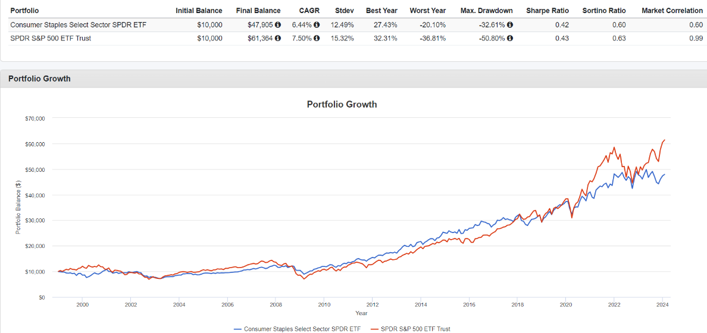
- Starting with $10k, the market has a final balance of $61k, while the consumer staples sector has $48k, so overall, the whole market has outperformed the consumer staples sector.
- The consumer staples sector has less volatility (i.e. standard deviation) compared to the market. This is because, as we said, we always buy consumer staples whether the economy is good or bad; there is no best period for the consumer staples sector.
- The consumer staples sector has less max drawdown compared to the market. A drawdown is the decline of an asset between the peak and the trough that follows. So, the max drawdown is the maximum declination. Usually, the market has higher max drawdown than any specific sector because, when a market crash occurs, all sectors fall down, so the market falls down way more than any single sector.
If we look back at the photo shown below that we have seen earlier, we can see that the consumer staples sector does exactly like the market in the early and mid phases, but outperforms the market in the late and recession phases. Expected, right? Because the consumers staples sector is very consistent, it performs in a certain manner whatever the economy’s conditions. This is why when the economy was not doing good (i.e. late and recession phases), the consumers staples sector outperformed the market. This is not because the consumers staples sector does better in these two phases, but it is because the market does worse.

Liquidity concept: liquidity means the volume of a stock. The more usual a stock is traded (i.e. the higher its average volume), the more it is liquid. Highly liquid stocks have their bid and ask prices very close to each other. For example, the difference between the bid and ask of Apple is just 1 cent as shown below:
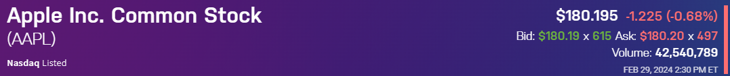
Spread: the spread is the difference between the bid and ask of a stock.
When is liquidity important? Assume you bought Apple’s share at the ask price $180.20. Next day, you decided to sell it, so you sell it at the bid price $180.19. Since Apple’s stock is very liquid, the difference between the bid and ask is very small (1 cent), so the cost of the spread here is small. Compare this to a case where the spread value is larger, the cost of buying and selling would be larger.
etf.com is a good website for comparing ETFs. Let’s use it to compare between XLP and another ETF that exactly does the same thing; replicates the consumer staples sector’s performance.
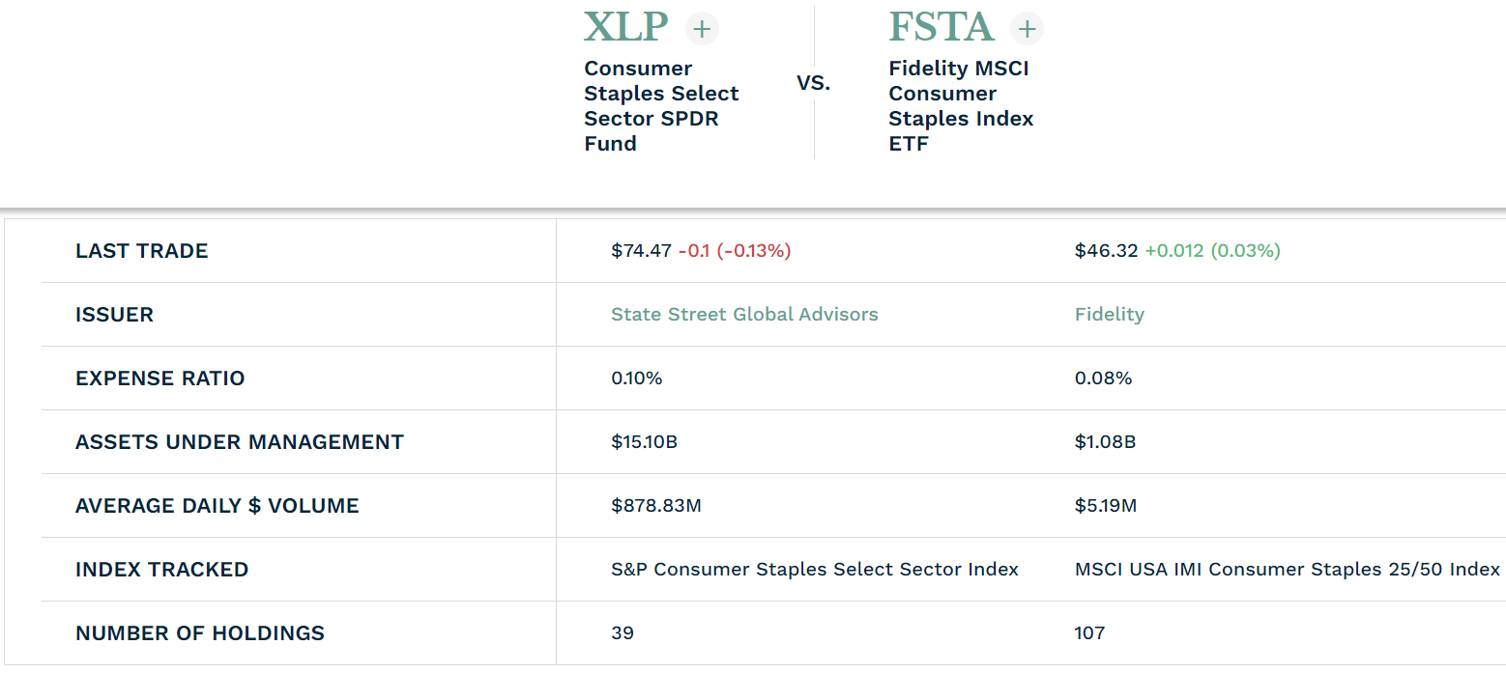
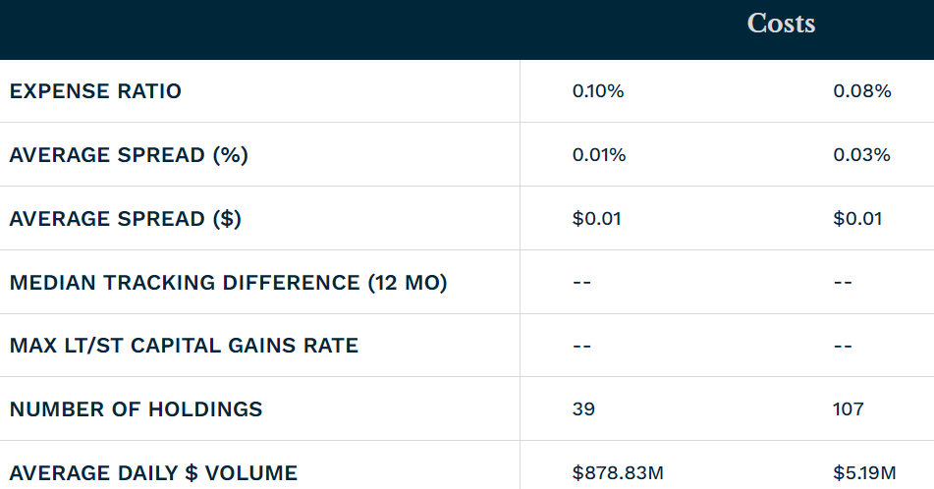
You can see that FSTA has less expenses ratio compared to XLP. So, why one might buy XLP instead? Because of liquidity! XLP has less average spread (0.01%) compared to FSTA (0.03%). Active traders like Mohsen Hassan prefer liquid stocks because they are active, they buy and sell a lot, they might buy an ETF one day and sell it next day, so they don’t want high spread cost. This is why Mohsen Hassan prefers XLP over FSTA. On the other hand, long-term investors won’t really care about spread, they would care more about expense ratio.

Energy Sector
The energy industry is the totality of all the industries involved in the production and sale of energy, including fuel extraction, manufacturing, refining and distribution.
Industries:
- Energy equipment & services.
- Oil, gas, and consumable fuels.
Sector sensitive to:
- The health of the economy (GDP, employment rate, etc).
- Price of commodities like oil and gas.
- Political events and regulations.
Popular US ETFs: XLE – FENY.
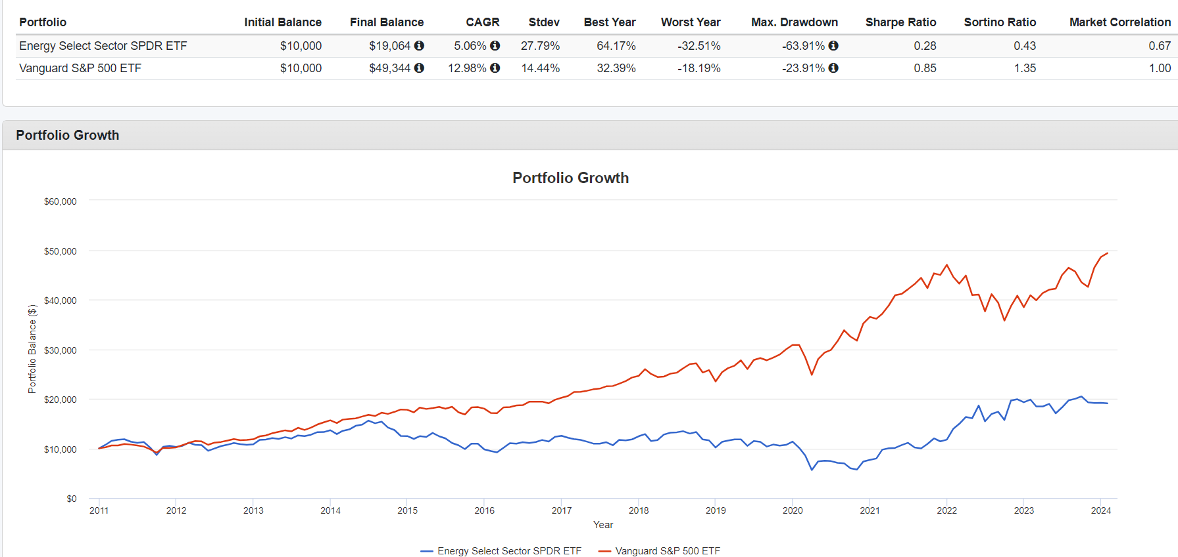
You can notice that the energy sector had a terrible performance from 2011 till 2021. In fact, when Mohsen Hassan was recording his course at the end of 2020, the energy sector showed -ve profit over the years! Does this mean we should not never include the energy sector in our portfolio? No, because “past performance doesn’t indicate future performance”. This is exactly what Mohsen Hassan said and look what happened next from 2021 to 2024, the sector did outstanding performance! In fact, it had an average annual profit of more than 70%! This again shows how important it is to diversify.

Materials Sector
The materials sector encompasses a wide range of commodity-related manufacturing industries. Included in this sector are companies that manufacture chemicals, construction materials, glass, paper, forest products and related packaging products, metals, minerals and mining companies, including producers of steel.
Industries:
- Chemicals.
- Construction Materials.
- Containers & Packaging.
- Metals & Mining.
- Paper & Forest Products.
Sector sensitive to:
- The health of the economy (GDP, employment rate, etc).
- Demand for consumer goods.
- Housing market.
Popular US ETFs: XLB – FMAT.
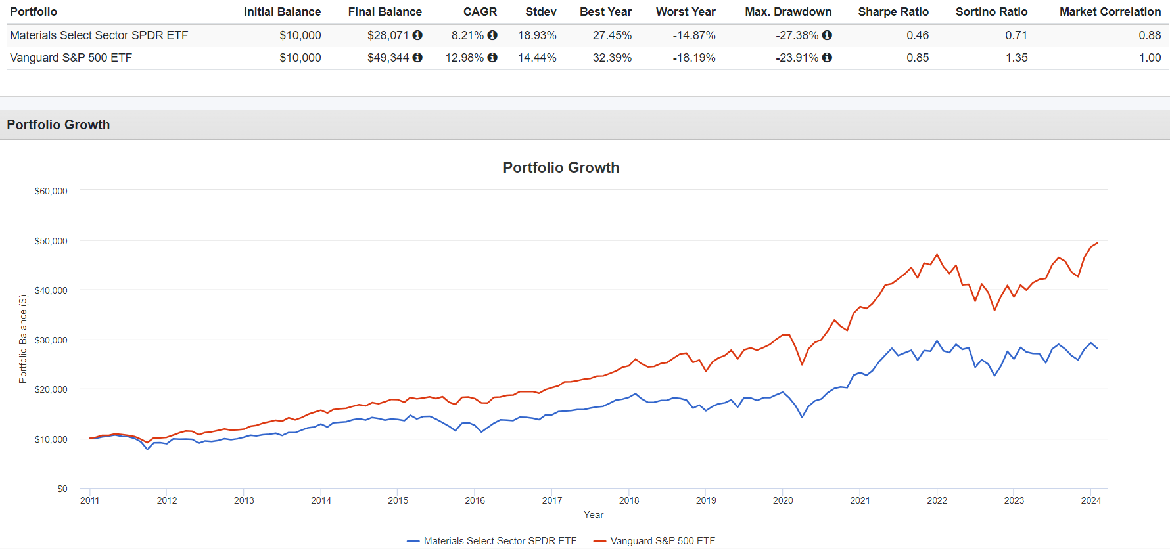

Industrials Sector
The industrials sector is comprised of companies that provide commercial and industrial products & services. The industrials sector is like the materials sector, but there are two key differences: first,
the products manufactured by companies in the industrials sector are not raw materials. For example, a company that produces farming tractors would be classified in industrials, but a mining company would
be classified in materials. Second, the industrials sector includes companies that provide products and services, whereas companies in the materials sector mainly create products.
Industry Group | Industries
Commerical & Professional Services | Commercial Services & Supplies  Professional Services
Transportation | Air Freight & Logistics  Airlines  Marine  Road & Rail  Transportation Infrastructure
Capital Goods | Aerospace & Defense  Building Products  Construction & Engineering  Electrical Equipment  Industrial Conglomerates  Machinery  Trading Companies & Distributors
Sector sensitive to:
- The health of the economy (GDP, employment rate, etc).
- Demand for consumer goods.
- Housing market.
Popular US ETFs: XLI – FIDU.
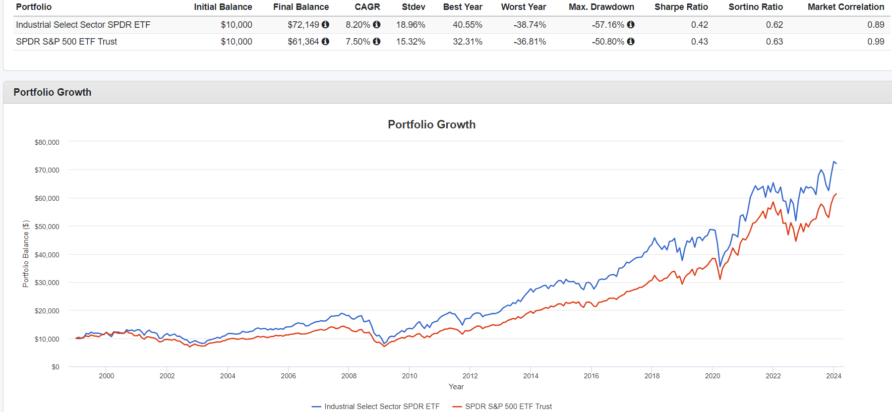

Consumer Discretionary Sector
Consumer discretionary refers to goods and services that consumers consider non-essential but desirable such as new clothes, cars, etc. It is -unsurprisingly- one of the most cyclic sectors.
Industry Group | Industries
Automobiles and Components | Auto Components  Automobiles
Consumer Durables & Apparel | Household Durables  Leisure Products  Textiles, Apparel & Luxury Goods
Consumer Services | Hotels, Restaurants & Leisure  Diversified Consumer Services
Retailing | Distributors  Internet & Direct Marketing Retail  Multiline Retail  Specialty Retail
Sector sensitive to:
- The health of the economy (GDP, employment rate, etc).
- Disposable income.
- Consumer confidence.
Popular US ETFs: XLY – FDIS.
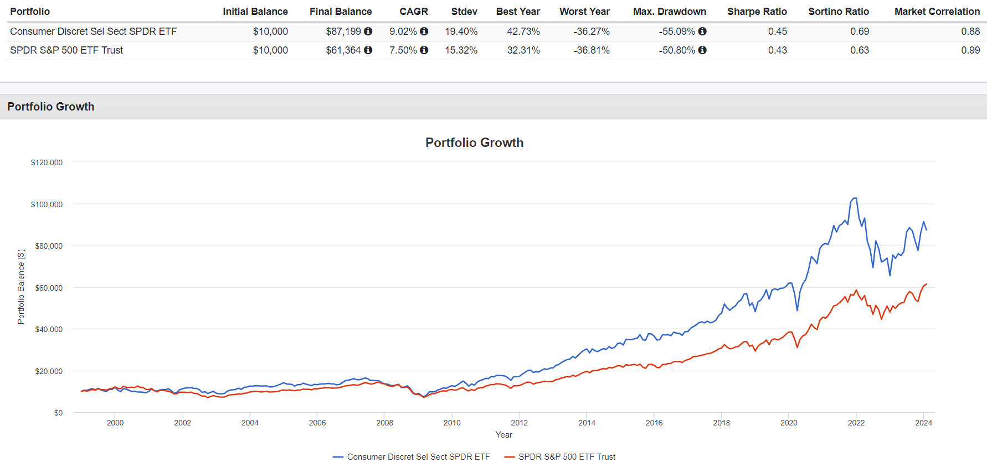

Healthcare Sector
The healthcare sector consists of businesses that provide medical services, manufacture medical equipment or drugs, provide medical insurance, or otherwise facilitate the provision of healthcare to patients.
Industry Group | Industries
Healthcare Equipment & Services | Health Care Equipment & Supplies  Health Care Providers & Services  Health Care Technology
Pharmaceuticals, Biotechnology, and Life Sciences | Biotechnology  Pharmaceuticals  Life Sciences Tools & Services
Sector sensitive to:
- Healthcare sector is noncyclical as the demand is usually the same regardless of economic outlook.
- Sensitive to government policies.
Popular US ETFs: XLV – FHLC.
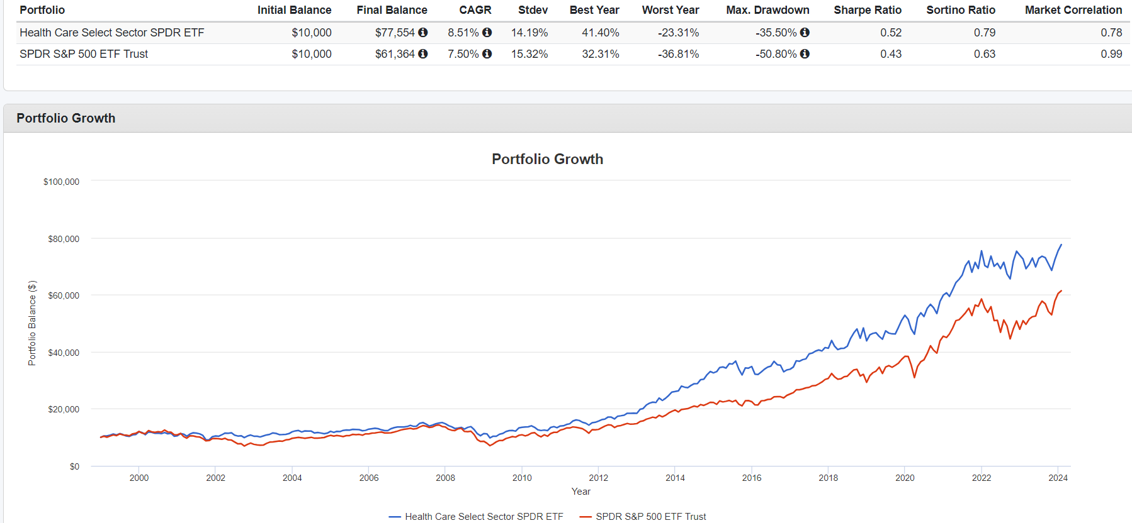

Financials Sector
The financials sector is composed of companies that provide financial services to other companies and/or to consumers. This includes services such as loans, credit, mortgage, insurance, wealth management and real estate.
Industry Group | Industries
Banks | Banks  Thrifts & Mortgage Finance
Diversified Financials | Diversified Financial Services  Consumer Finance  Capital Markets  Mortgage Real Estate Investment Trusts (REITS)
Insurance | Insurance
Sector sensitive to:
- Early phase sensitive.
- Interest rates.
Popular US ETFs: XLF – FNCL.
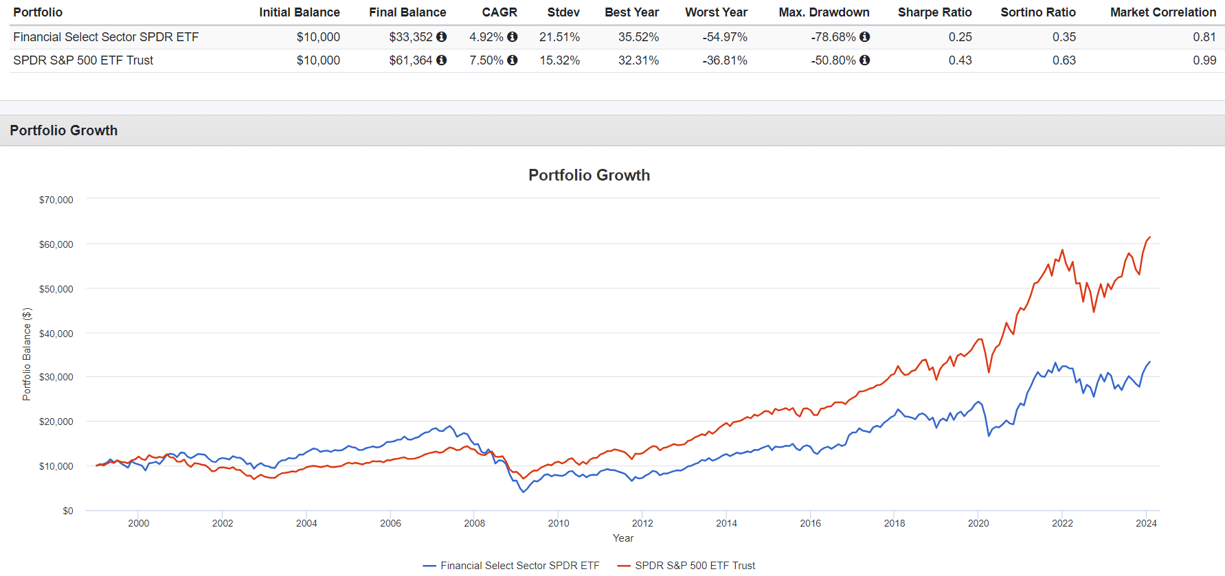
It is clear how the financial sector deteriorated after the 2008 financial crisis.

Information Technology Sector
The technology sector is the category of stocks relating to the research, development and/or distribution of technologically based goods and services. This sector contains businesses revolving around the manufacturing of electronics, creation of software, computers or products and services relating to information technology.
Industry Group | Industries
Software & Services | IT Services  Software
Technology Hardware & Equipment | Communications Equipment  Technology Hardware, Storage, and Peripherals  Electronic Equipment, Instruments, and Components
Semiconductors & Semiconductor Equipment | Semiconductors & Semiconductor Equipment
Sector sensitive to:
- Economy health.
- Overperform in early/mid business cycle.
- Underperform in late/recession business cycle.
Popular US ETFs: XLK – FTEC.
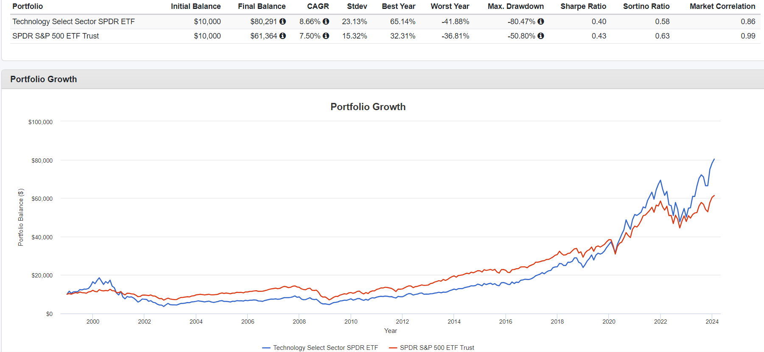
It is clear how the information technology sector deteriorated after the tech-bubble crisis in 2000-2002.

Communications Services Sector
Companies that provide communication services using fixed-line networks or those that provide wireless access and services. This sector also includes companies that provide internet services such as access, navigation and internet related software and services.
Industry Group | Industries
Telecommunication Services | Diversified Telecommunication Services  Wireless Telecommunication Services
Media and Entertainment | Media  Entertainment  Interactive Media & Services
Sensitive to:
- The health of the economy (GDP, employment rate, etc).
- Used to be telecom sector (changed to Communication Services in 2018).
- Now includes FB, NFLX & GOOG so is more cyclical than before (used to only include telecom which are more stable throughout the business cycle).
Popular US ETFs: XLC.
Note: original telecom companies only represent 11% of the new Communication Services sector. The rest are companies that were once in the tech or discretionary sectors. So, future returns/risk can be completely different.

Utilities Sector
The utilities sector is comprised of companies that provide or transmit electricity, gas or water to businesses and consumers. This sector also includes companies that provide electricity through renewable energy sources, such as solar or hydro power, and companies that generate and sell energy to utility
companies.
Industries:
- Electric Utilities.
- Gas Utilities.
- Multi-Utilities.
- Water Utilities.
- Independent Power and Renewable Electricity Producers.
Sector sensitive to:
- Utilities sector is noncyclical as the demand is usually the same regardless of economic outlook.
- Considered a defensive sector.
- Usually highly regulated by the government.
Popular US ETFs: XLU – FUTY.
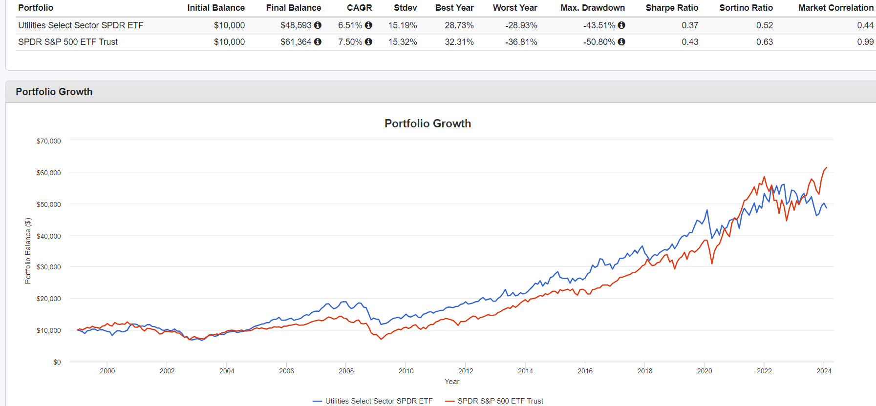

Real Estate Sector
It includes equity real estate investment trusts (REITs) and companies engaged in real estate development and operation. Over recent years, the Real Estate sector’s domestic orientation and relatively high payout yields have made it attractive, particularly in an environment of low and falling interest rates.
Industries:
- Equity Real-State Investment Trusts (REITs).
- Real Estate Management & Development.
Sector sensitive to:
- Economy health.
- Interest rates.
Popular US ETFs: XLRE – SCHH.
